# Shell Script Assignment

**Mandatory:**

1. Create a script named “myscript” in current directory to do the following.
2. display “hello user”



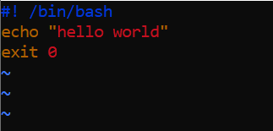:

1. list files in current directory



1. name of logged in user



1. date



1. Add execute permission and Run the script from
2. current directory

ls

1. Create a subdirectory named “test”

:



1. Change to “test” directory. Run the script “myscript” [Hint: You will have to update PATH to include the directory containg script to run script from any location].

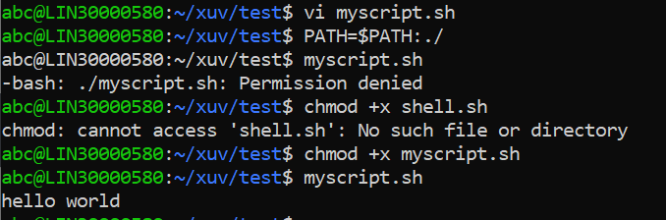

**Optional Assignments:**

1. Considering command line arguments are accessible using $<position> i.e

$0- for first argument

$1- for second argument…

write a shell script to concatenate all command line arguments using ‘_’ and display it as a single string.

Refer example below

$>./myscript.sh ABC DEF

Output:

ABC_DEF

[Refer <http://linuxcommand.org/lc3_wss0120.php>]